Team Sarawut 20/30
Pretty good effort. Basic text and pictures. Covered the myths in good detail and was all written in their own words.

Team Timothy 30/30
Very impressive presentation. A great amount of effort including an introduction, which was extra work on top of an already substantial body of work. Was written as chapters, like a book.
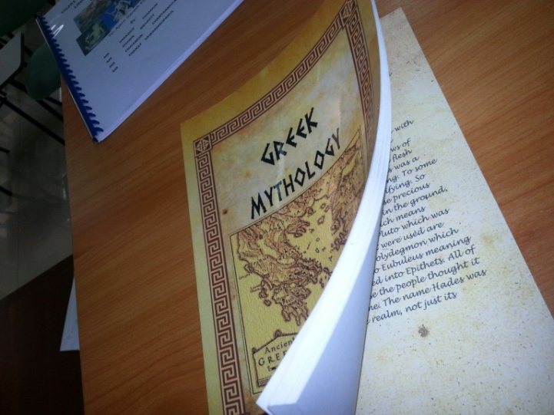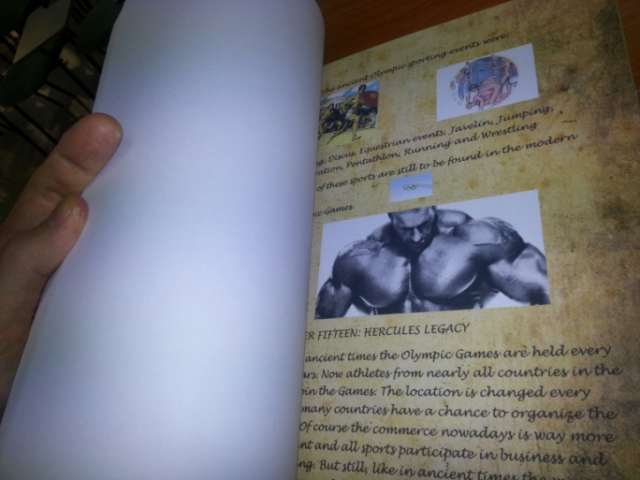
Team Clive 18/30
Pretty good effort. Basic text and pictures. Covered the myths in good detail and was written in their own words. A few typos here and there and was also double spaced.
Team Pratley 30/30
A lot of effort in presentation and good detail in the information. There were different sections presented for each myth such as ‘imagery’ ‘origins’ etc which was designed to appear like a scroll when combined with the ancient font that was used.
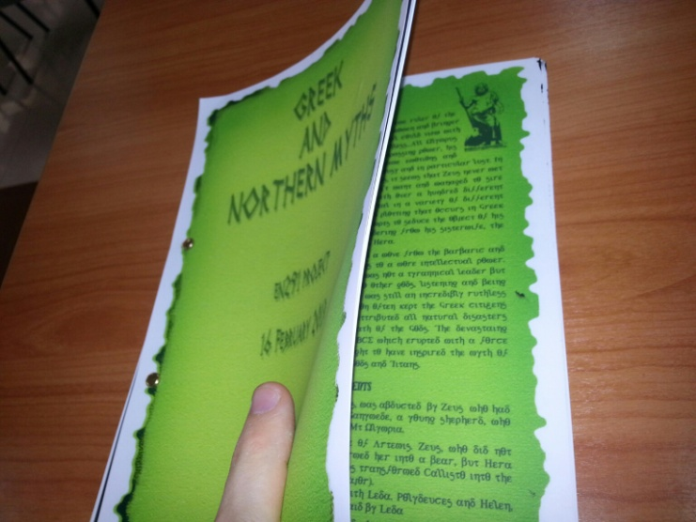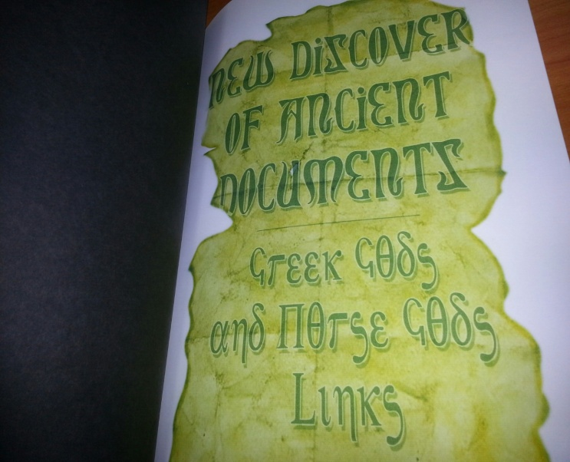
Team Gerber 30/30
Quite a remarkable piece of work. Up there with the very best work I have ever received. An incredible amount of effort and completely original idea. There were thoughtful touches everywhere, including the back page which was designed like a Greek TV advertisement for a tragedy. Also, within the magazine, there were various features set against the backdrop of a modern day lifestyle magazine like ‘romance sections’ etc. It is a shame 30 is the top score. This is certainly a 30++ project.
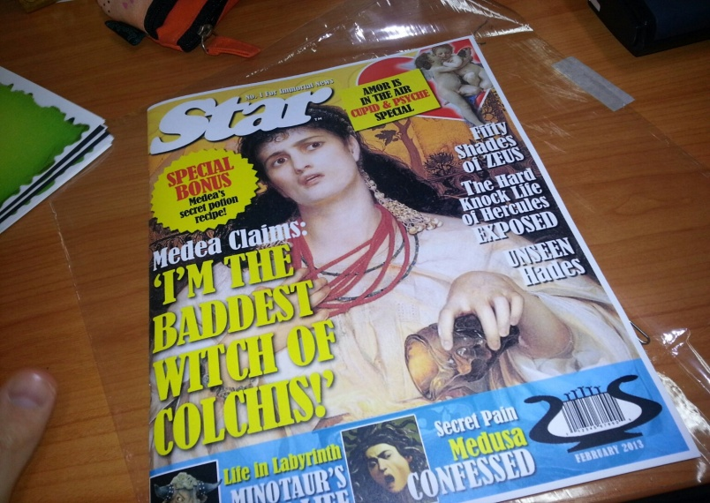

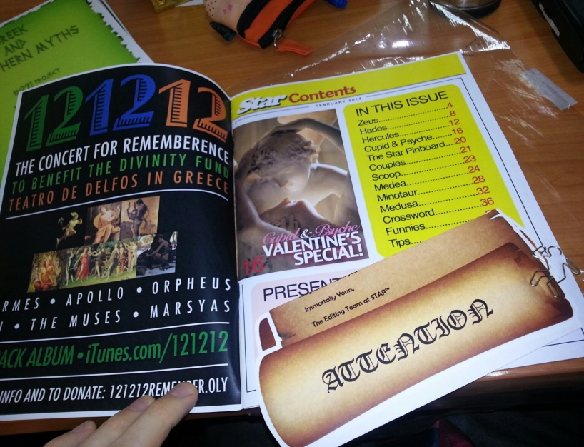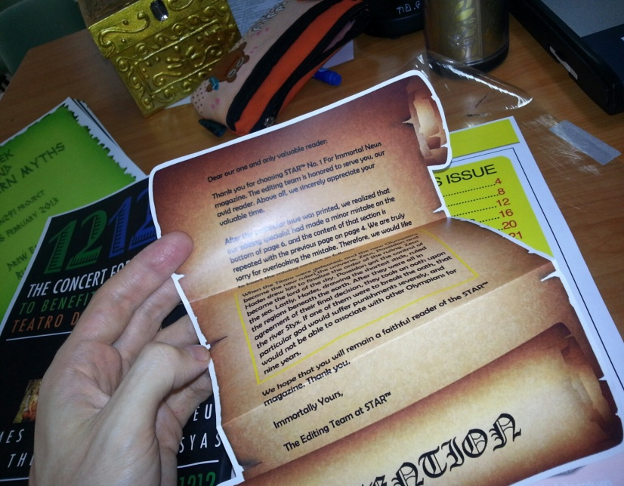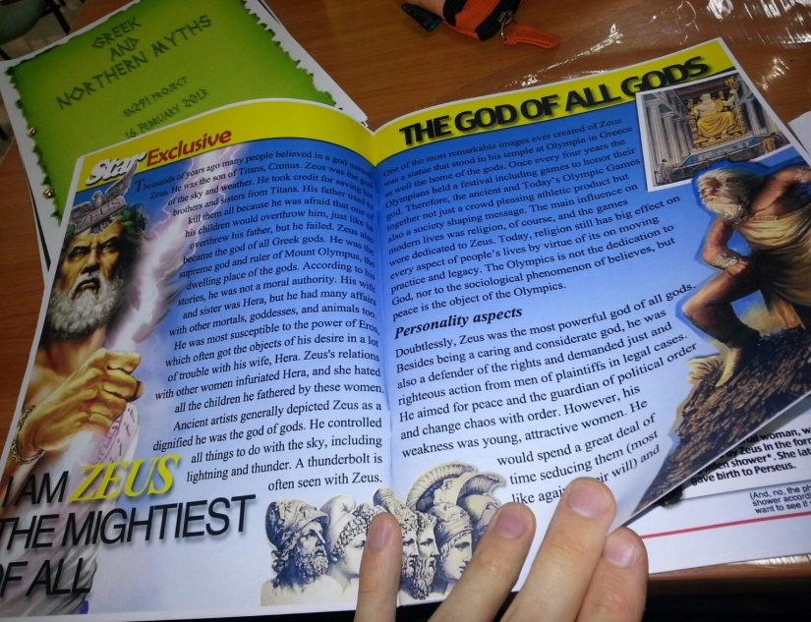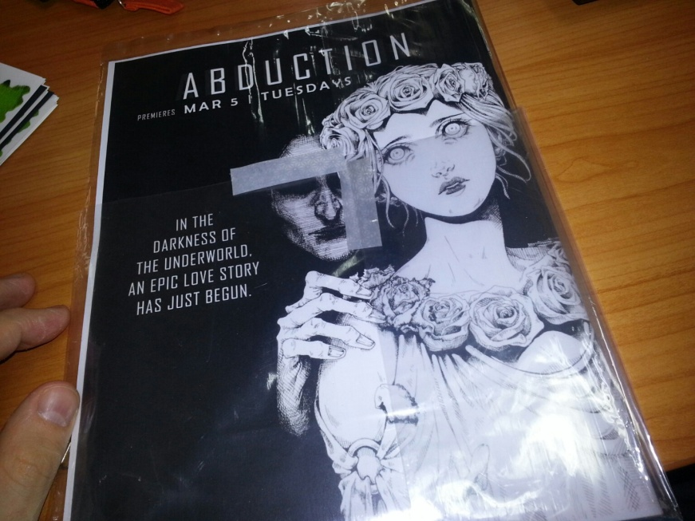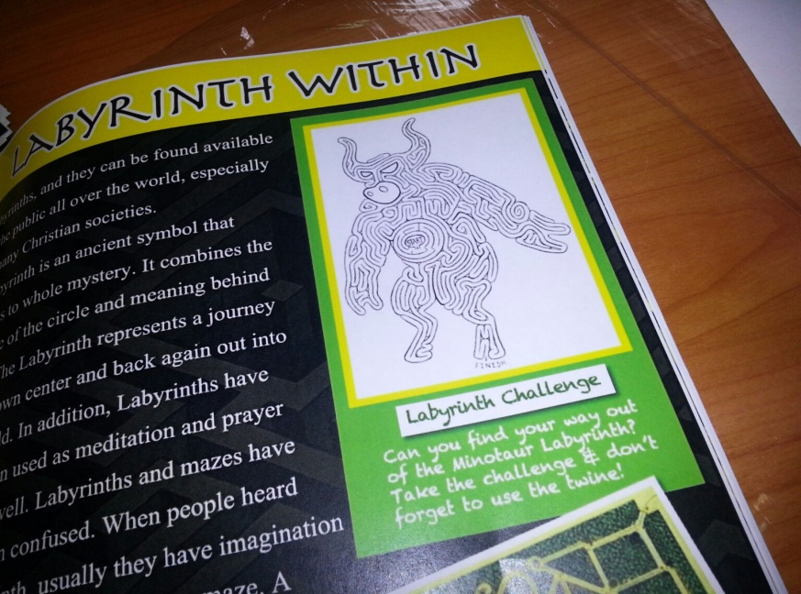

Team Famela 30/30
Another remarkable piece of work (handed in just after I had written the above group’s feedback). This is equally remarkable, particularly in terms of the presentation, which stands alone. Nice little touches with faces of students (and me) photoshopped in different places on the face of gods. I will try and find a nice place in the IIS building for this work to hang. It is interactive as well. 30++ score
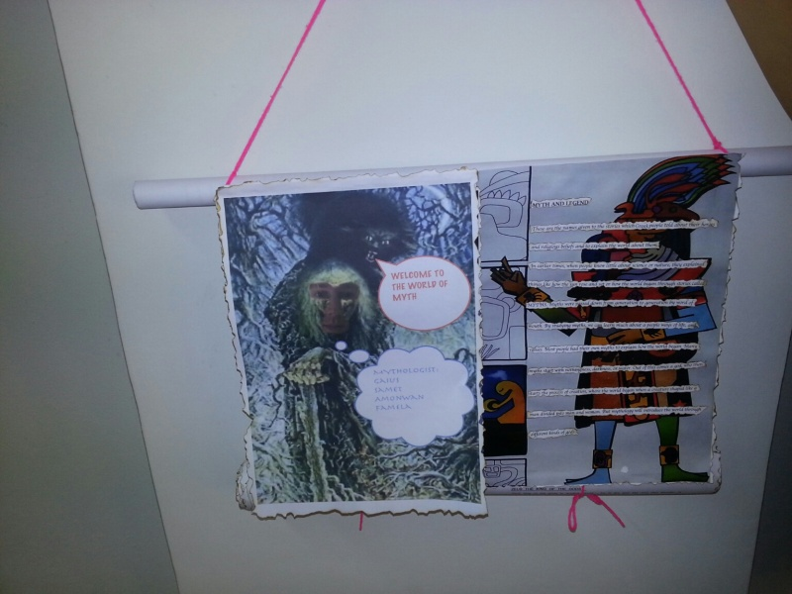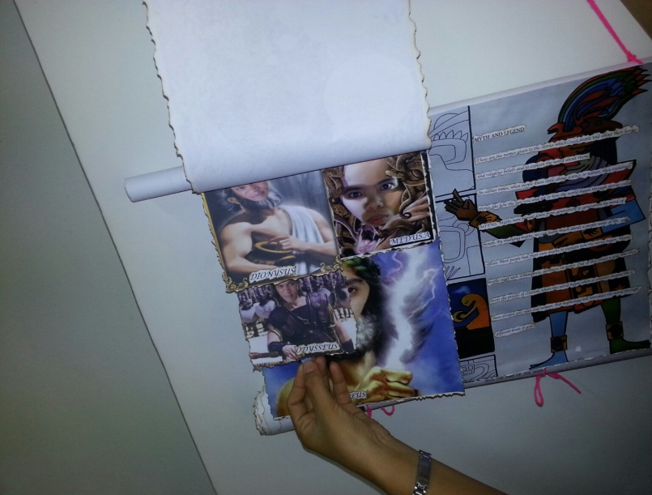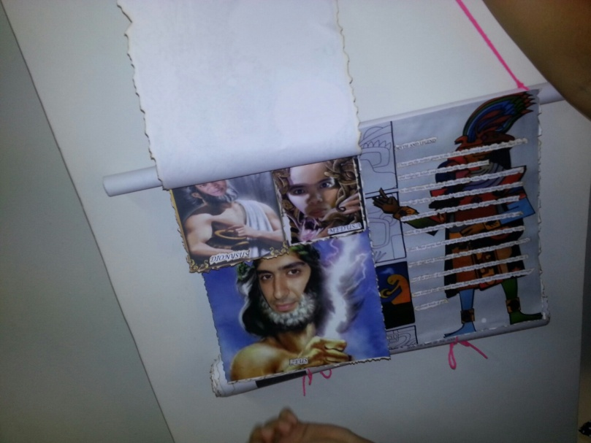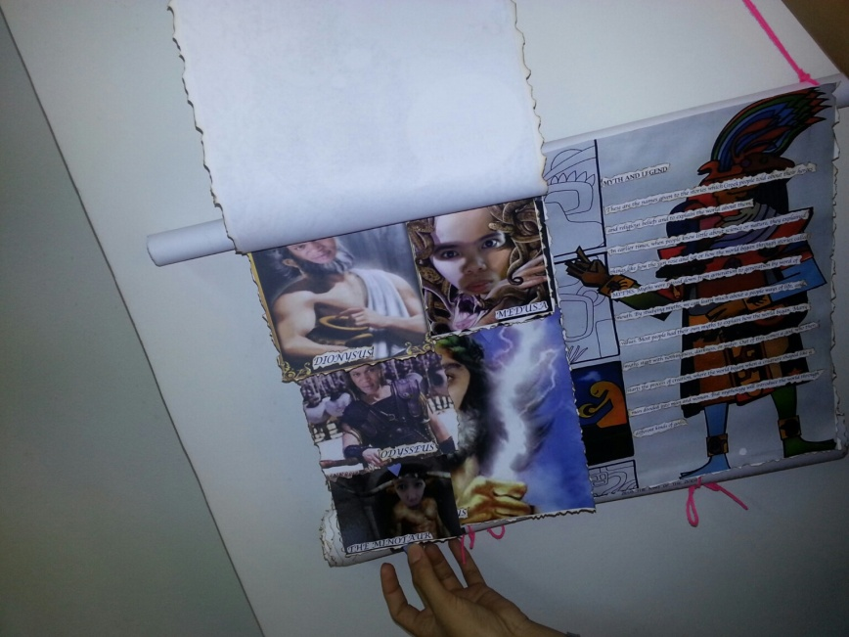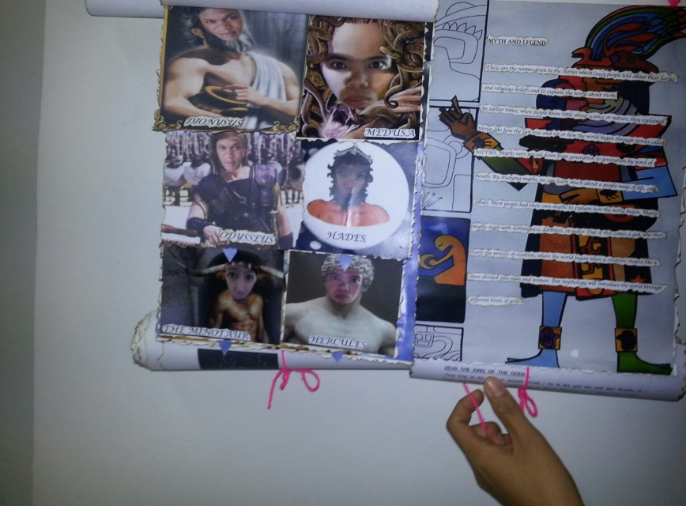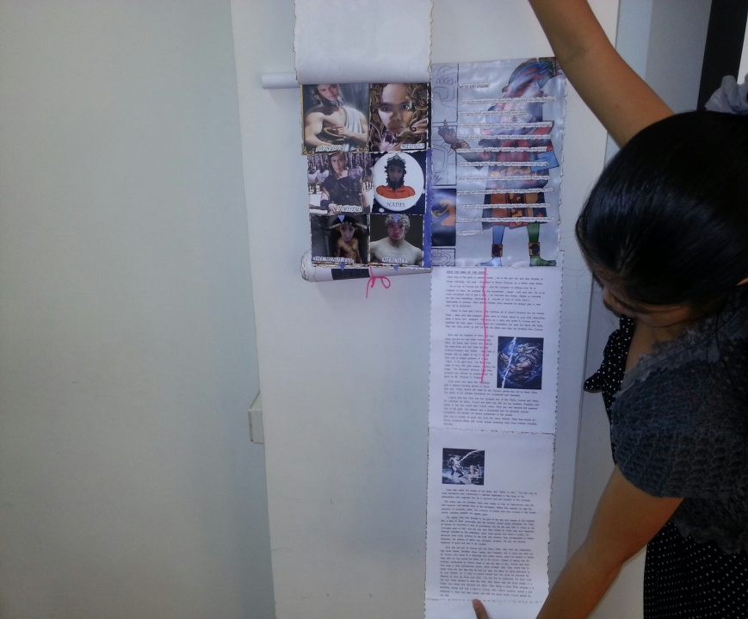

Team Nalinee 30/30
I am beginning to run out of superlatives. This one however may take the biscuit. Just a magnificant effort with an incredible amount of time put in. A ‘treasure trove’ box of mythological scrolls. I wish I could display this forever more in the IIS building, but alas, I would feel guilty keeping it. It even included arty little testicles. This one lives in the memory, just like myths of old. 30+++

