ENG 2901 Course Folders Evening Class – Information, Grading Scheme and Examples

Information (Evening Class)
You must hand in one course folder per team. Each folder must contain information on different myths/characters. The number of myths you cover is determined by the number of members in your group. For example
2 members-2 myths
3 members-3 myths
4 members-4 myths

You can choose from any of the following:

-Zeus
-Hercules
-Hades
-The Minotaur
-Medusa
You are free to choose the style of your folder (see below for some excellent examples of original work). The amount of work you put in will directly affect the grade you get. Copied or plagiarized work will result in either a FAIL or a low score for your group.

Grading Scheme
30
Perfect, original, a large amount of effort, covered main topics as requested

25
Very good, a lot of effort and evidently followed the task very well

20
Good work with maybe some elements missing or incomplete or maybe not enough focus on originality/presentation

15
A generally good effort with original input but maybe some elements of copying or a lack of originality

10
Followed the task well but didn’t really go to much effort apart from satisfying the task. Some original work or too many unaltered texts. Could just be too little writing.

5
Mainly used work from the internet with little original input, but presented well and with some effort

2
Work copied and pasted off the internet with the aim of putting in no effort apart from that it was presented in a folder

0
Nothing submitted

NOTE:
I sometimes put scores in between these boundaries if I think work does not quite fit into one category

Examples
Team A 30/30
Very impressive presentation. A great amount of effort including an introduction, which was extra work on top of an already substantial body of work. Was written as chapters, like a book.
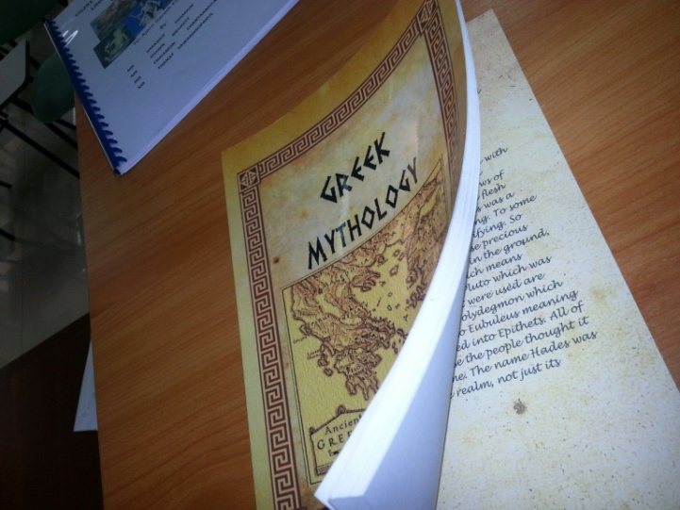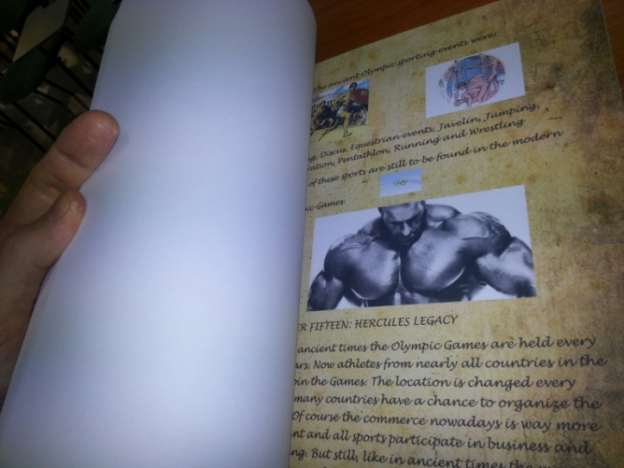
Team B 30/30
Quite a remarkable piece of work. Up there with the very best work I have ever received. An incredible amount of effort and completely original idea. There were thoughtful touches everywhere, including the back page which was designed like a Greek TV advertisement for a tragedy. Also, within the magazine, there were various features set against the backdrop of a modern day lifestyle magazine like ‘romance sections’ etc. It is a shame 30 is the top score. This is certainly a 30++ project.
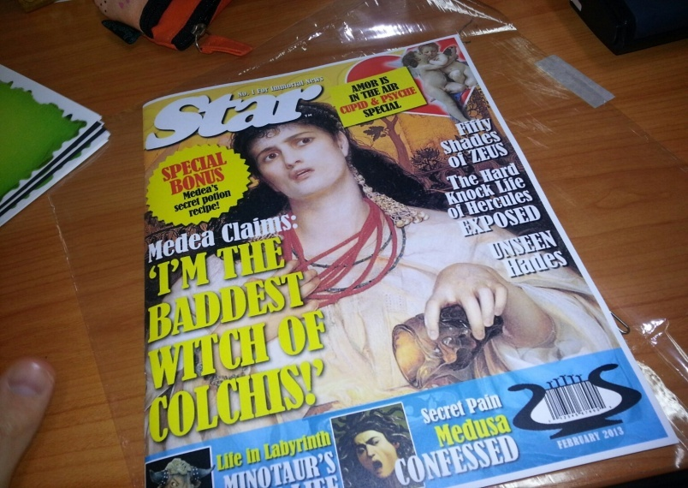

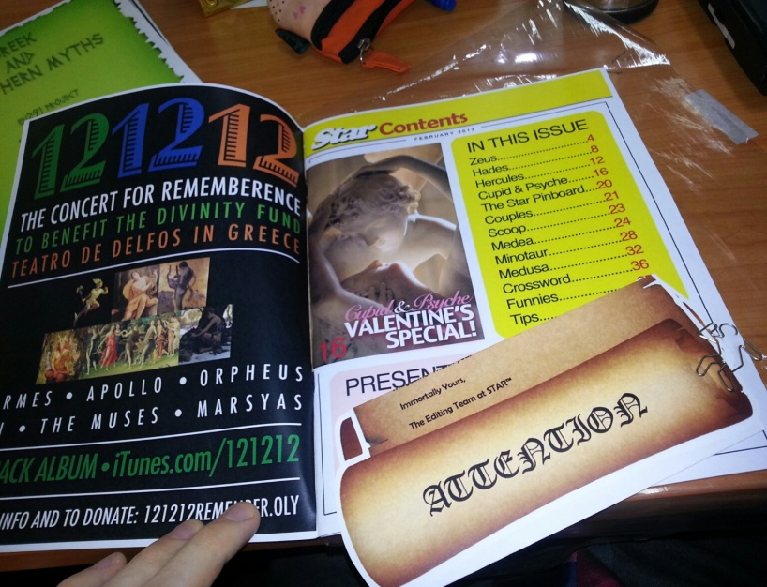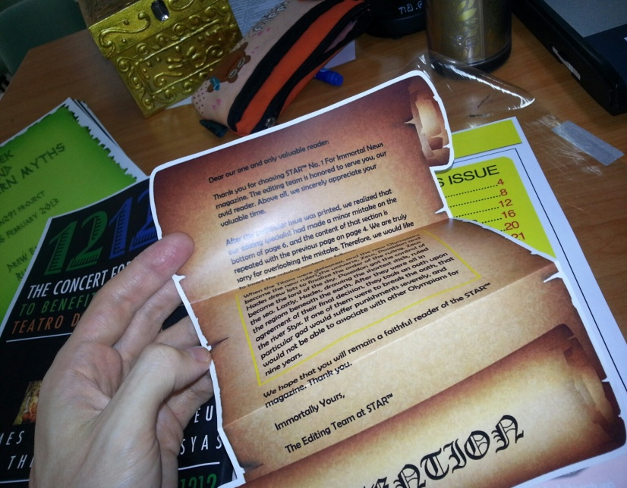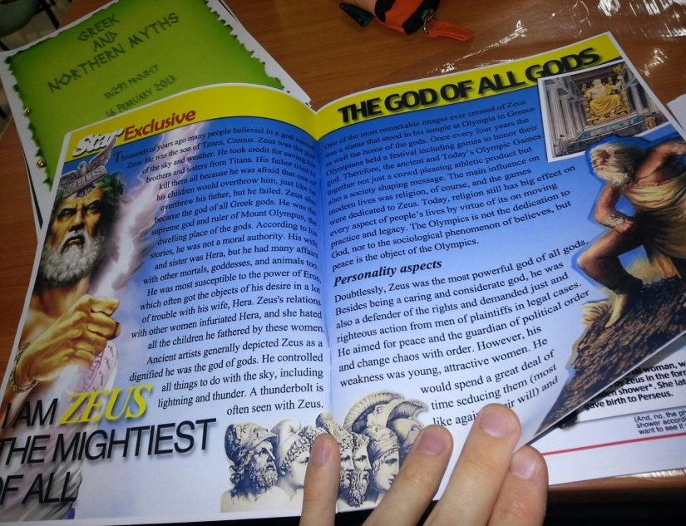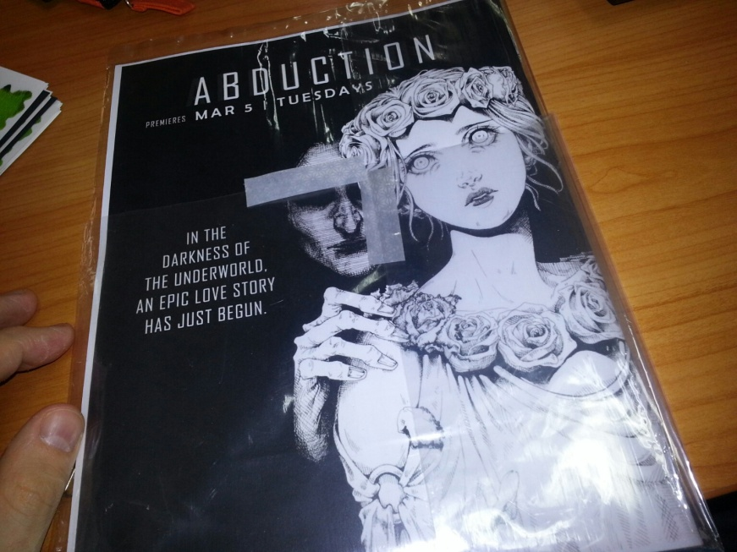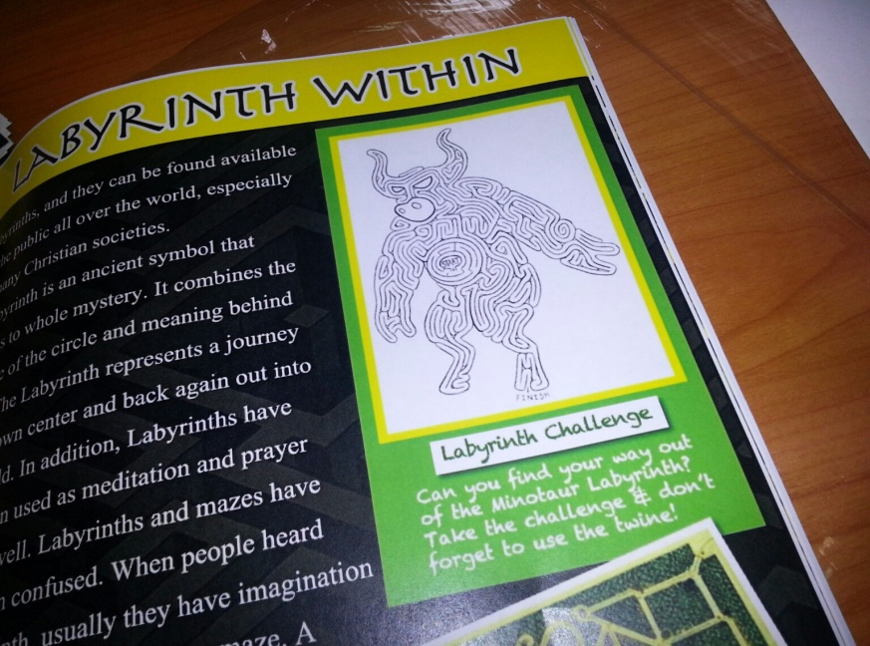

Team C 30/30
Another remarkable piece of work (handed in just after I had written the above group’s feedback). This is equally remarkable, particularly in terms of the presentation, which stands alone. Nice little touches with faces of students (and me) photoshopped in different places on the face of gods. I will try and find a nice place in the IIS building for this work to hang. It is interactive as well. 30++ score
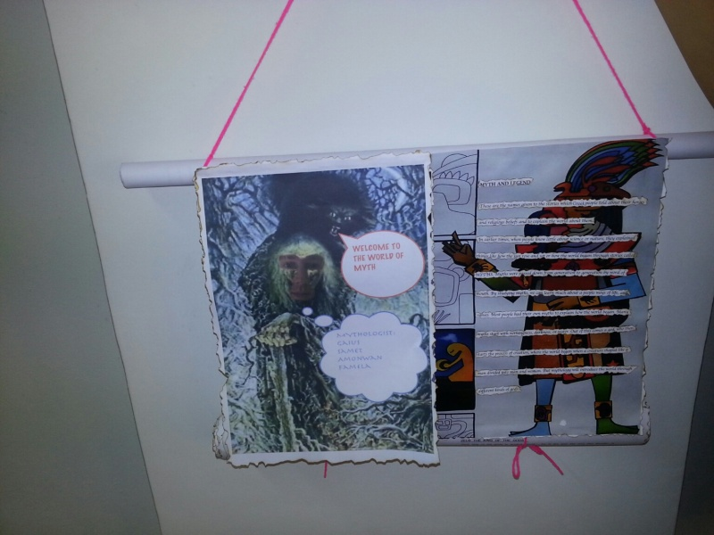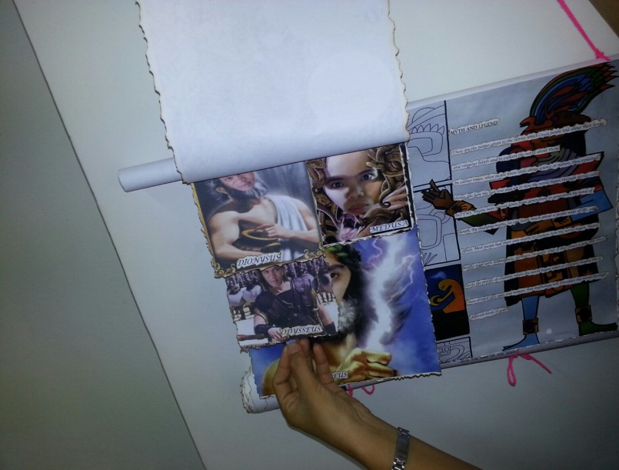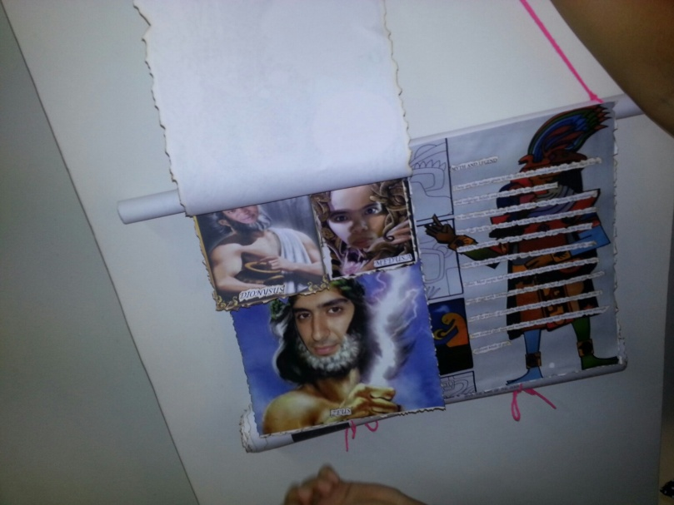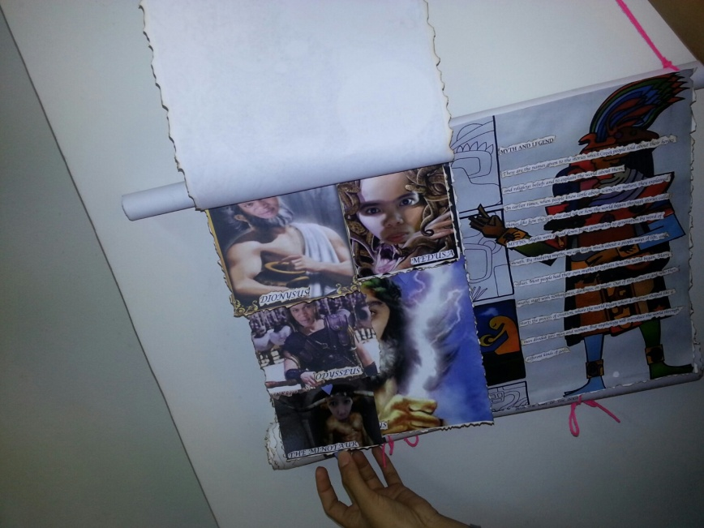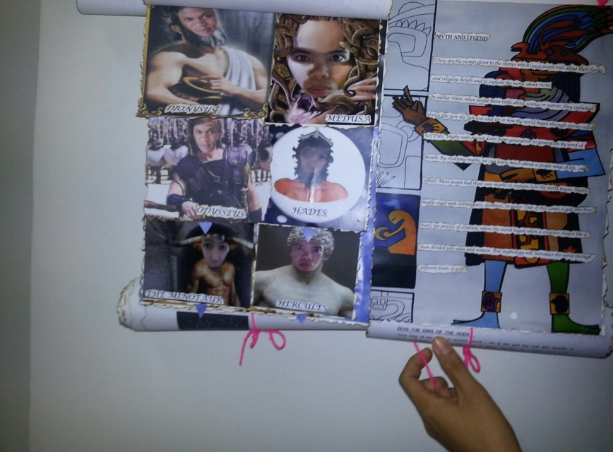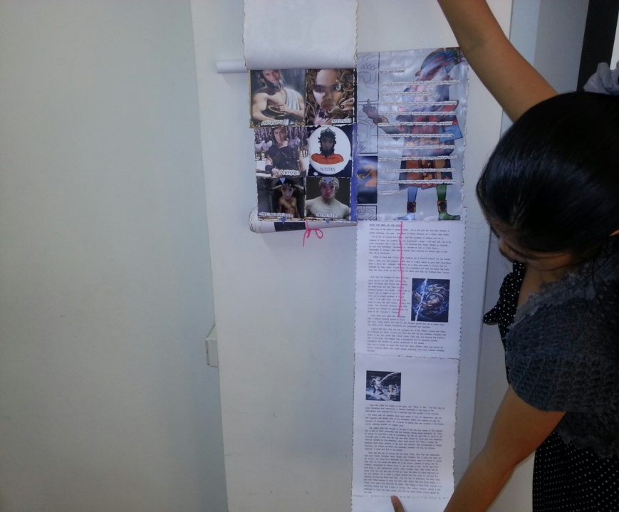

Team D 30/30
I am beginning to run out of superlatives. This one however may take the biscuit. Just a magnificant effort with an incredible amount of time put in. A ‘treasure trove’ box of mythological scrolls. I wish I could display this forever more in the IIS building, but alas, I would feel guilty keeping it. It even included arty little testicles. This one lives in the memory, just like myths of old. 30+++

